



**CSU Sacramento**

**Department of Electrical Engineering**

**Lab 7: PSpice Lab**

**Sam Lee**

**Partners: Jordan Moore, Jeffrey Hawthorn, Awfa Al-Rakabi**

**EEE 117L Network Analysis Laboratory**

**March 22nd, 2019**

**Professor Sergio Aguilar Rudametkin**

**Section: 01**

**Day: Monday**

**Time: 5pm-7:40pm**

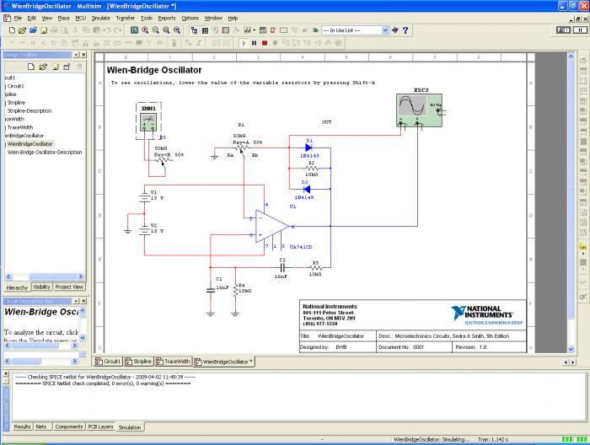

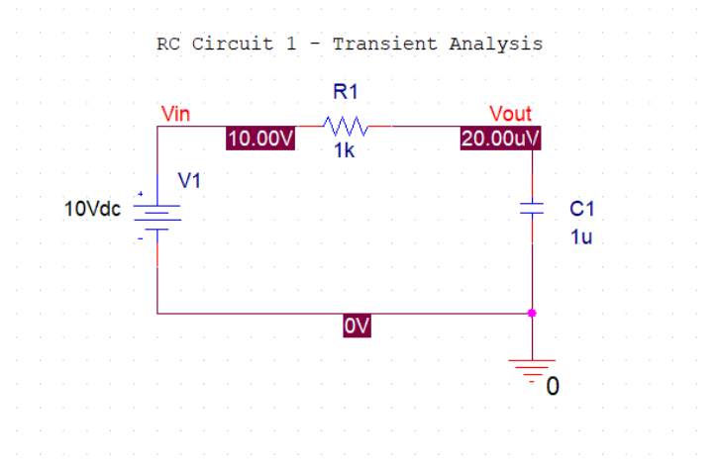

Figure 7.1: RC Circuit #1 – Transient Analysis

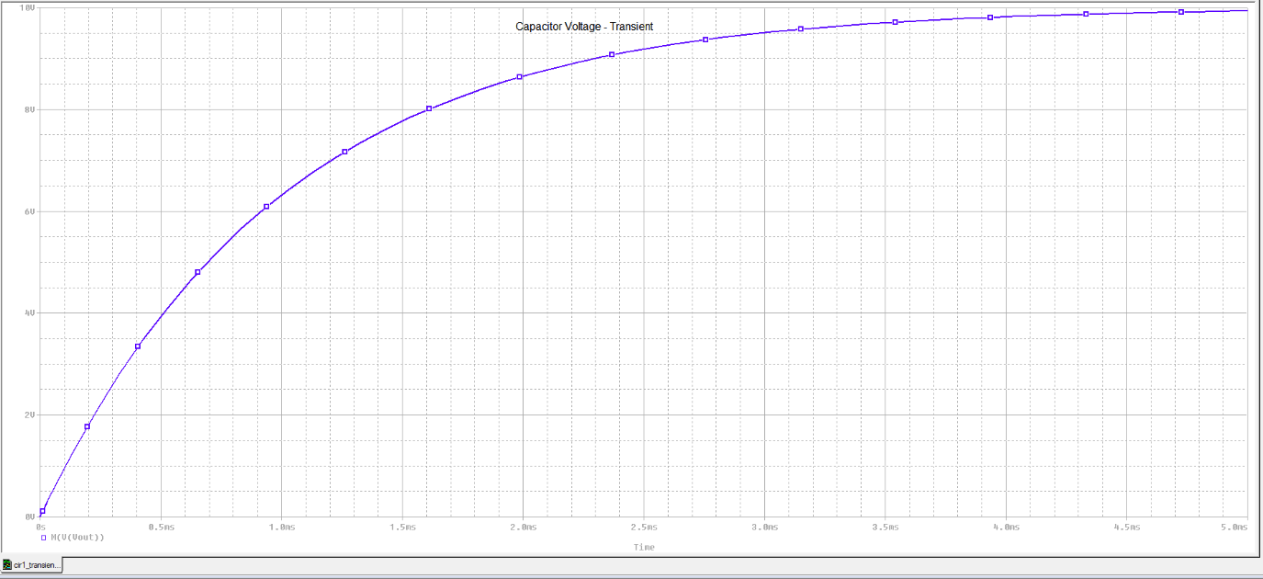

Figure 7.2: Trace of RC Circuit #1 - Transient Analysis

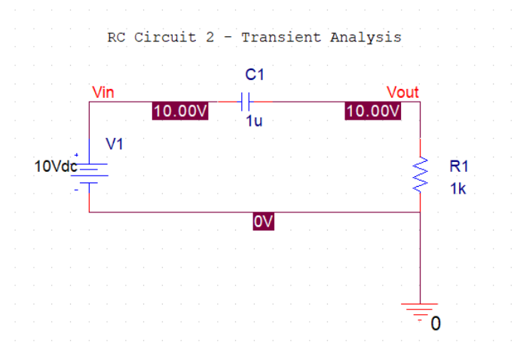

Figure 7.3: RC Circuit 2 – Transient Analysis

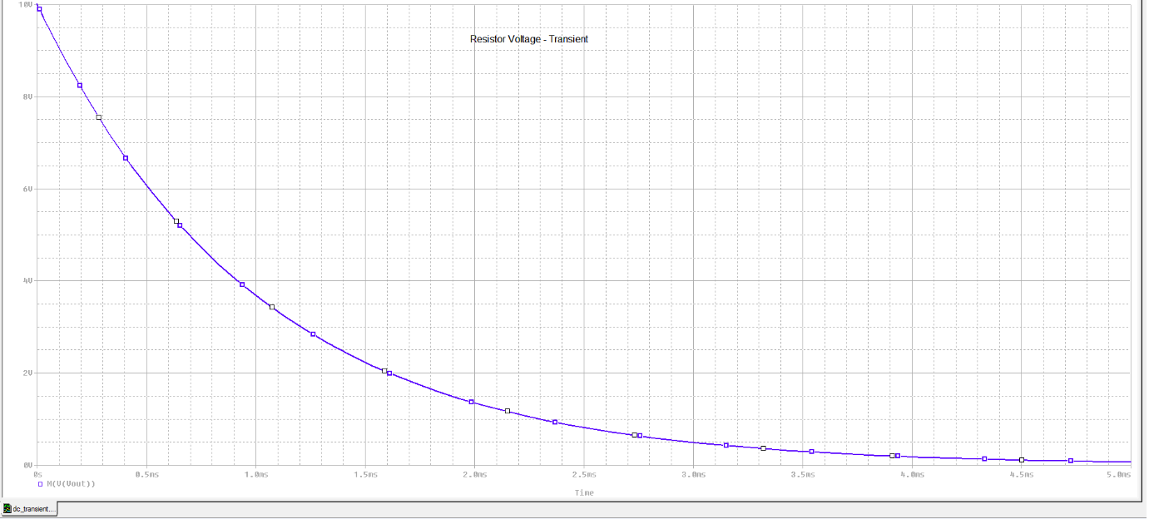

Figure 7.4: Trace of RC Circuit 2 – Transient Analysis

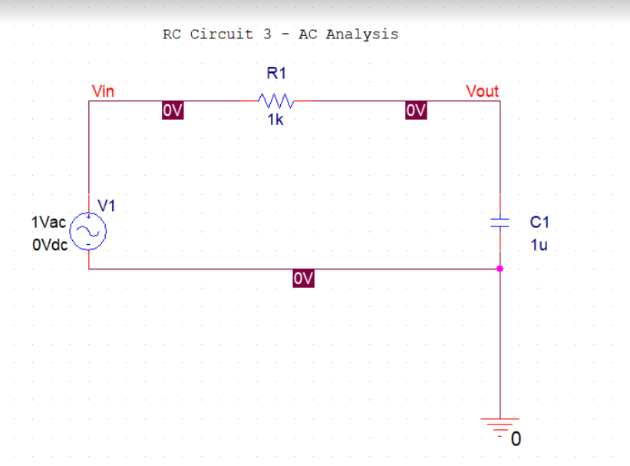

Figure 7.5: RC Circuit 3 – AC Analysis

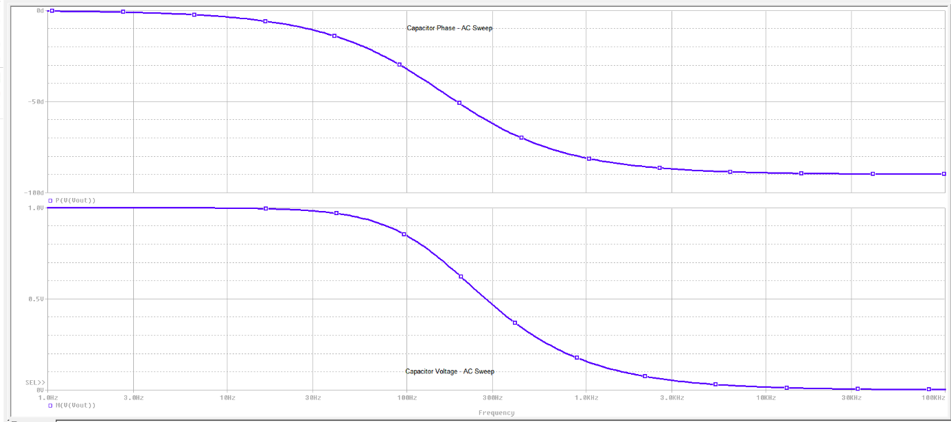

Figure 7.6: Trace of RC Circuit – AC Analysis

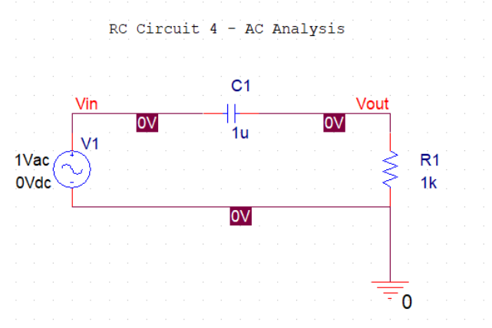

Figure 7.7: RC Circuit 4 – AC Analysis

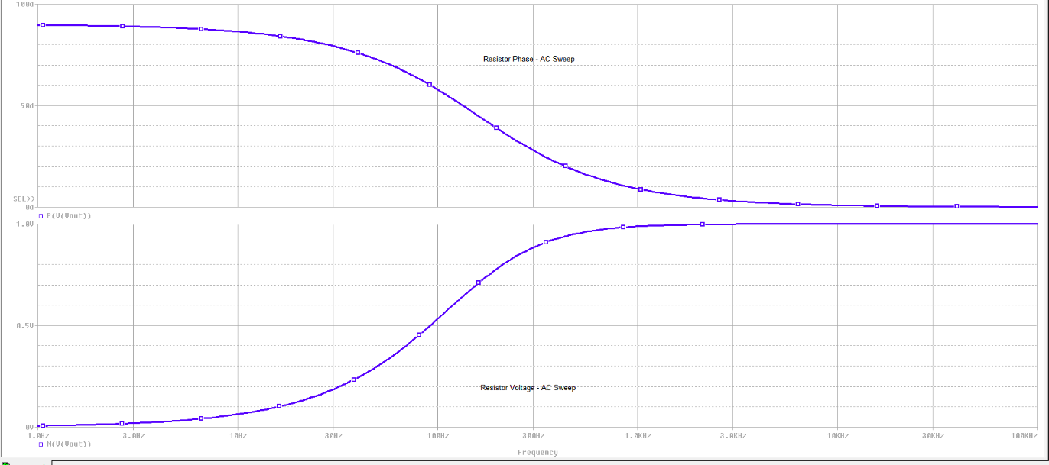

Figure 7.8: Trace of RC Circuit 4 – AC Analysis